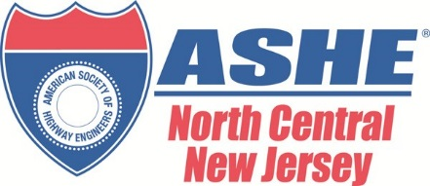

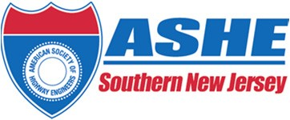
AMERICAN SOCIETY OF HIGHWAY ENGINEERS (ASHE)
NORTH CENTRAL & SOUTHERN NEW JERSEY SECTIONS
2022 PROJECT OF THE YEAR AWARD

The North Central and Southern New Jersey Sections of the American Society of Highway Engineers (ASHE) invite you to participate in its 2022 Award Program to honor consulting engineering firms, contractors, and transportation officials in their efforts to provide quality roadway facilities in New Jersey.

To be eligible, the projects must be a roadway related construction project located within the State of New Jersey that has demonstrated the use of some unique or innovative features concerning design elements, design delivery process, scheduling, construction techniques, equipment, and contracting methods to complete the project. The construction of the projects must have been completed in 2020, 2021 or 2022. Non‐winning prior year entries may be resubmitted.

This year there will be two (2) Projects of the Year Awards. There will be one (1) for the less than
$10M total construction cost category, and one (1) for the over $10M total construction cost category. The selections will be based on the highest composite score of the following criteria:

25% Complexity
25% New Application of Existing Technologies/Originality/Innovation
15% Social/Economic Considerations
15% Safety
10% Aesthetics and Sustainable Features
10% Meeting and Exceeding Owner’s/Client’s Needs

In the event of a numerical tie, the projects with the tie score will be voted on by the judges in a “run‐off” style election with each judge casting one vote for the winning project. The project that receives the highest vote total shall be the winner.

Entries must be prepared by personnel knowledgeable of the project and in responsible charge of the work. The Project’s Owner must be notified and approve of the submission as required. The electronic entry package must be received by Friday March 18, 2022. Awards will be presented at the ASHE North Central and Southern New Jersey joint cocktail and dinner reception. The date and location will be announced shortly.

ASHE NJ 2022 PROJECT OF THE YEAR

Entry Information
Entries should be submitted in PDF format. Email zipped or EFTP files to Stella.Karcnik@wsp.com. Please note that portions may be used for the ASHE section websites. The winning presentations will be presented on the evening of the awards.

- Completed Entry Form. (See attached below)

- Executive Summary. Briefly summarize the main aspects of the project. The Executive Summary shall not exceed one (1) page, printed in font size no smaller than ten‐point. The Executive Summary shall be in an “article” format and may be re‐printed in the ASHE newsletter.

- Project Description. Describe clearly and concisely what the Designer and Contractor did on this project to be considered for the four evaluation criteria. This narrative should be in non‐technical language easily understood by a layperson. If the project was completed ahead of schedule, provide the reduction in contract completion time. If the project was completed under budget, provide the project cost data (using original bid price and owner’s estimate if available). The Project Description shall not exceed five (5) pages, printed single sided in 12‐point font on 8” X 11” paper.

- Photographs. Include up to 5 color photographs no bigger than 8 ” X 11”.

- Credits. The entrant must provide a list of credits including the Owner, the General contractor, the Designer, and any other significant participants of the submitted project.

- Display Panel, one (1) original. The Display Panel shall be 30” X 30” and include a drawing or graphical representation of the project. Clearly identify this material with the title of the entry. (Include a 30” X 30” size PDF of this in the electronic submission due March 18,2022. Mail or hand deliver a foam core poster prior to the awards ceremony.)

All entry materials submitted will not be returned and will become the property of the American Society of Highway Engineers. All entries will be displayed at the April ASHE meeting. A maximum of one display board will be permitted per project entered. In addition, the winning entries will be advertised in both the ASHE Southern NJ & NCNJ web sites. Judges will include Transportation Agency Officials, Academia and/or Government Officials.

ENTRY CHECKLIST

- Submittal Binder (electronic)
  - Executive Summary (1‐page maximum)
  - Project Description (5-page maximum)
  - Color Photographs (5 maximum)
  - List of Credits

- Entry Form (electronic)

- Display Panel (30” X 30”) PDF. (Mail or hand deliver foam core presentation board prior to the awards ceremony.)

Mail display boards to:

ASHE Project of the Year Committee c/o WSP
200 Lenox Drive, 3rd floor
Lawrenceville, New Jersey 08648
Attn: Stella Karcnik

Please call Stella Karcnik at (609) 512‐3475 or email at Stella.Karcnik@wsp.com if you have any questions regarding entry materials.

ASHE NJ 2022 PROJECT OF THE YEAR

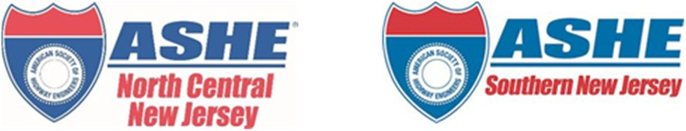

AMERICAN SOCIETY OF HIGHWAY ENGINEERS (ASHE) NORTH CENTRAL & SOUTHERN NEW JERSEY SECTIONS
2022 PROJECT OF THE YEAR AWARD

ENTRY FORM

Project Name
Location
Date of completion
Total construction cost

APPLICANT DATA

OWNER
Name
Contact Person
Address
Phone

DESIGNER
Name
Contact Person
Address
Phone

CONTRACTOR
Name
Contact Person
Address
Phone

